**HR database exercises**

Use the lab_HR database script to create and populate the tables regions, departments, job_history, countries, employees, locations, jobs and job_grades. This is the database model for your reference: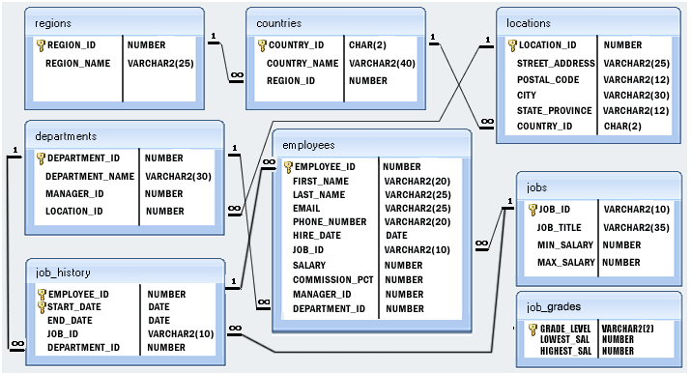

1. Write a query to display the names (first_name, last_name) using alias name “First Name", "Last Name".

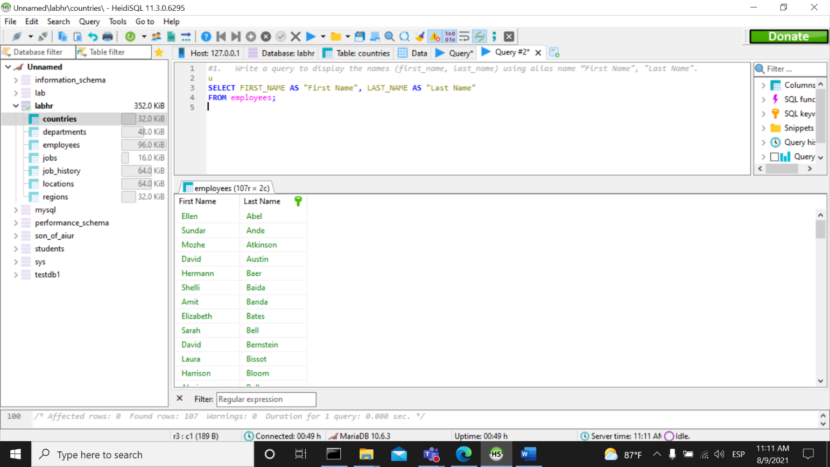

1. Write a query to get unique department ID from employee table.

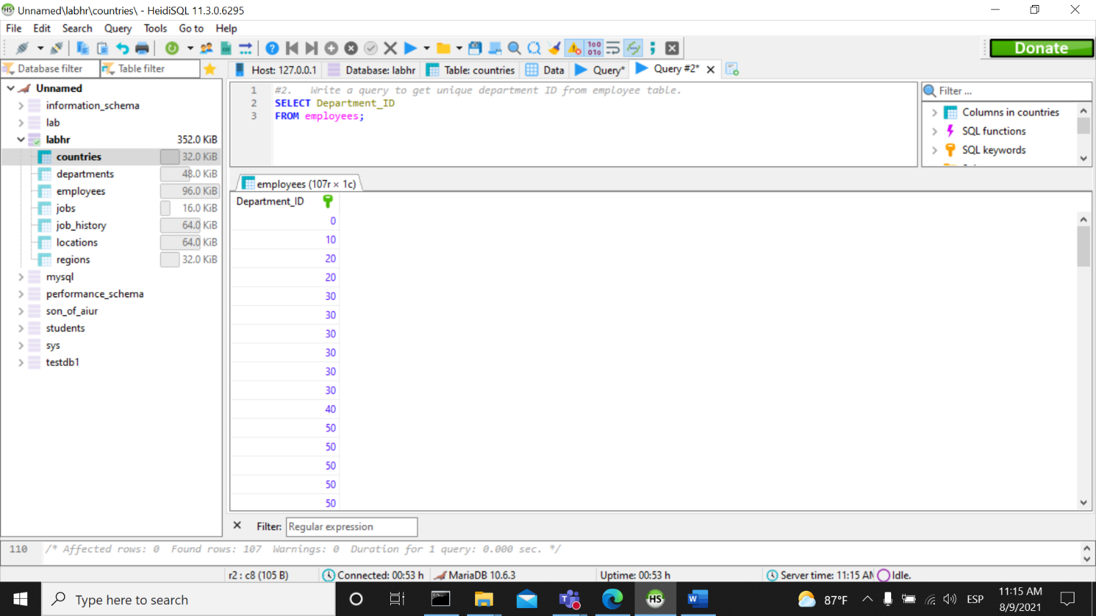

1. Write a query to get all employee details from the employee table order by first name, descending.

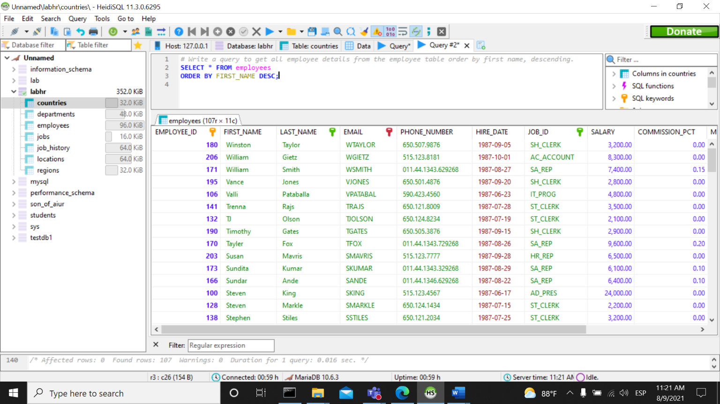

1. Write a query to get the names (first_name, last_name), salary, PF of all the employees (PF is calculated as 15% of salary).

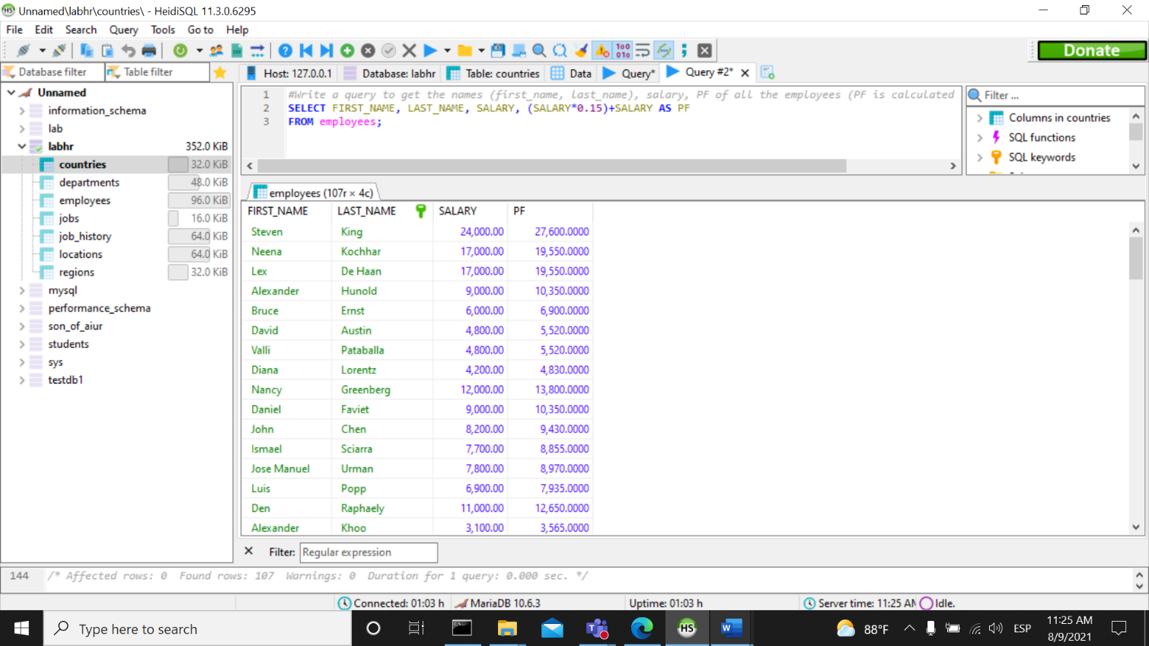

1. Write a query to get the employee ID, names (first_name, last_name), salary in ascending order of salary.

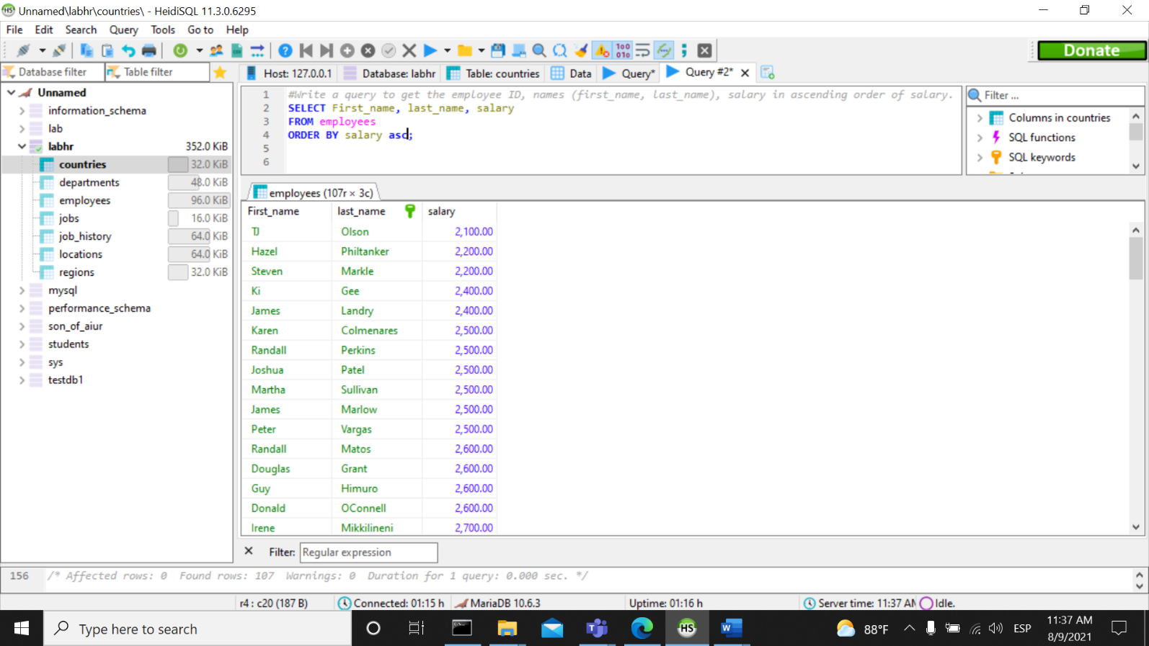

1. Write a query to get the total salaries payable to employees.

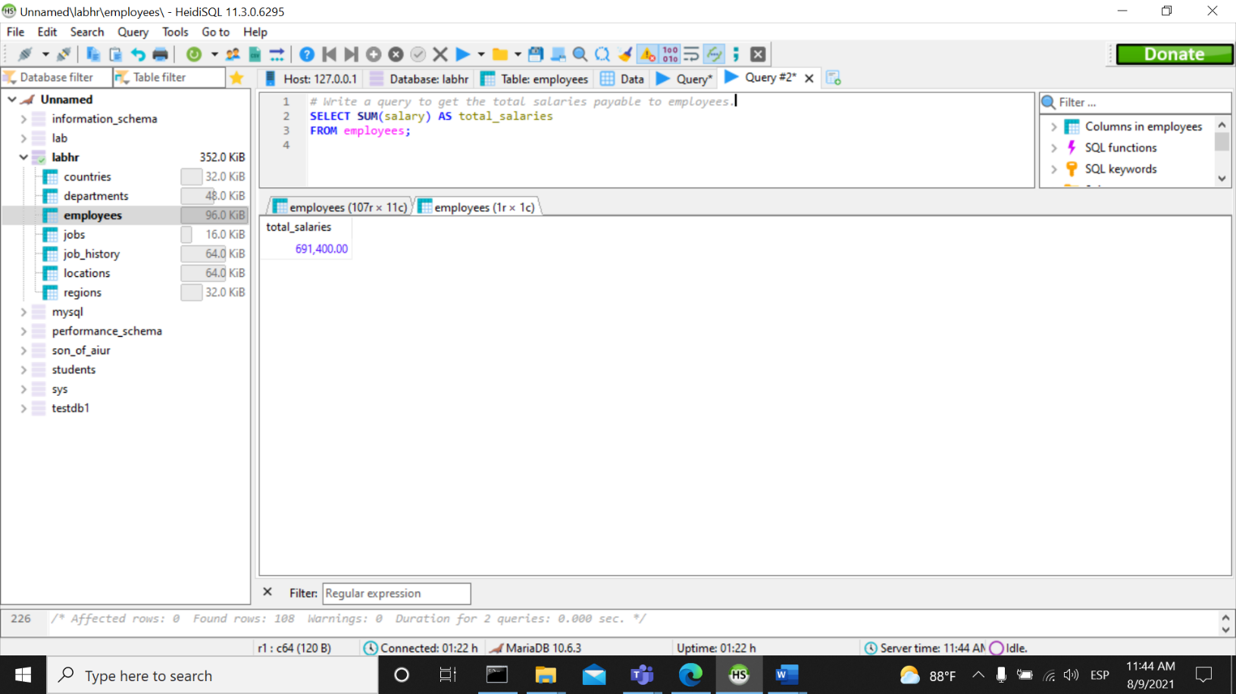

1. Write a query to get the maximum and minimum salary from employees table.

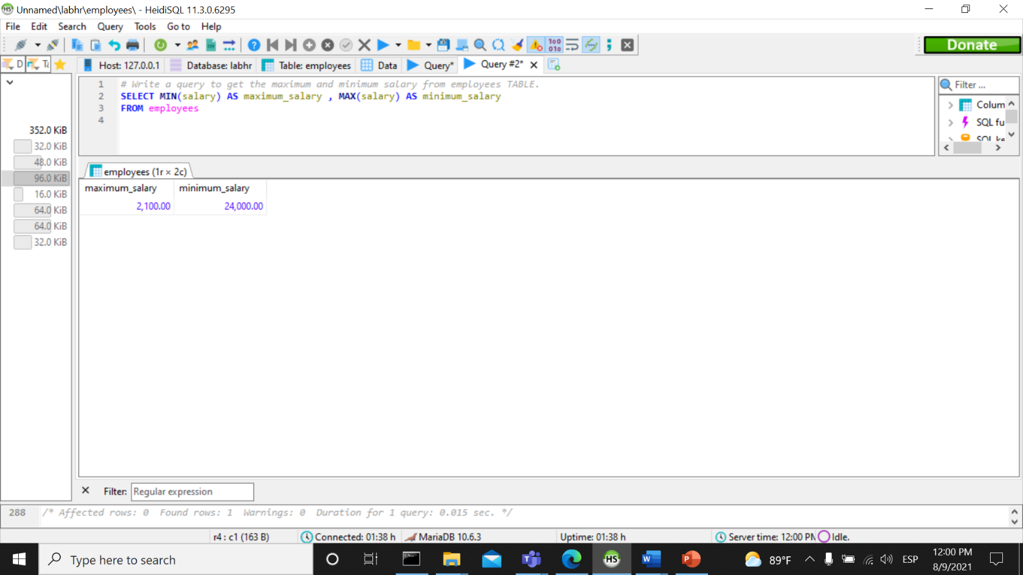

1. Write a query to get the average salary and number of employees in the employees table.

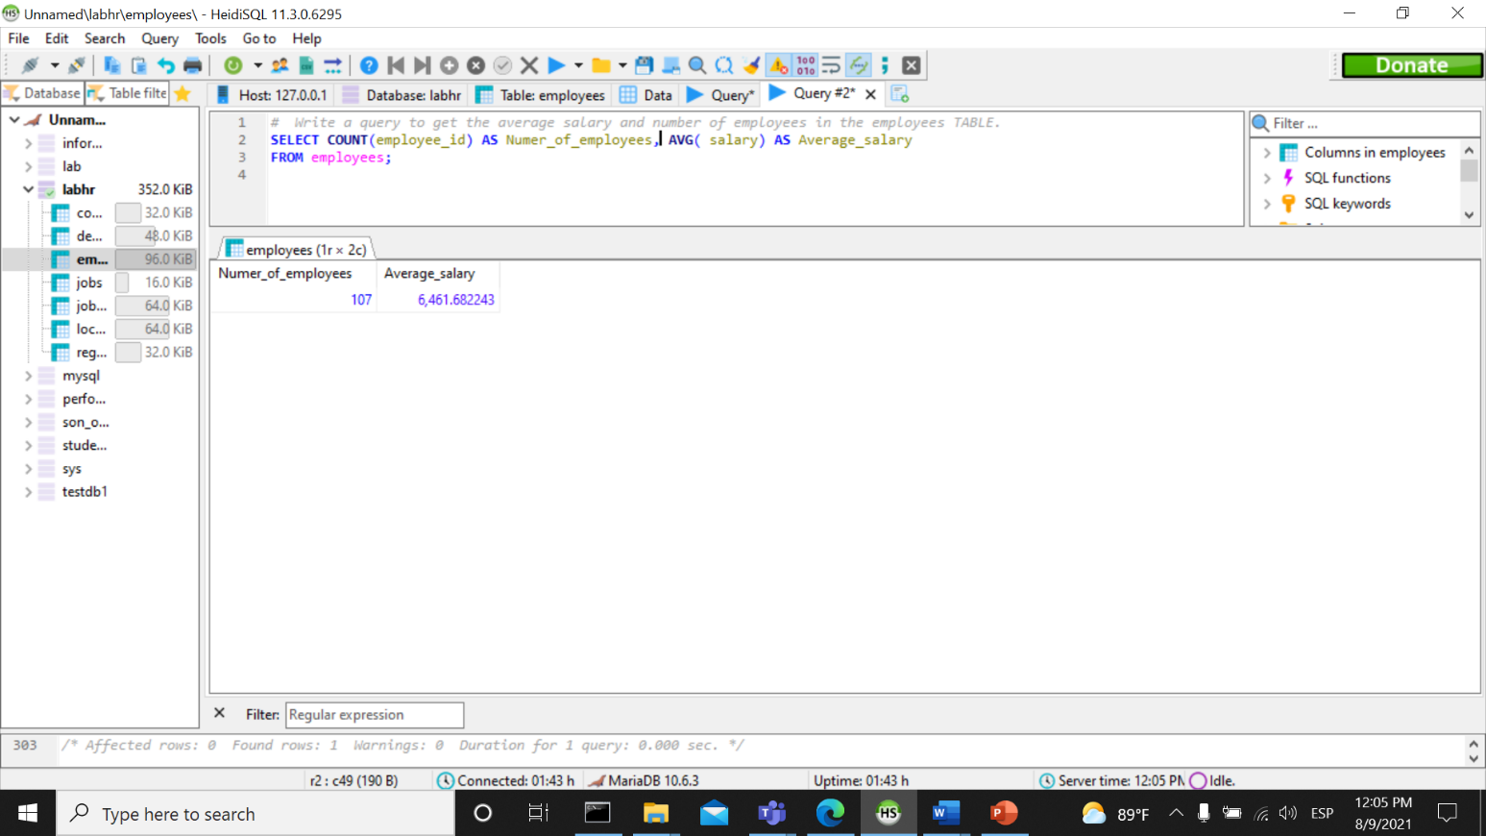

1. Write a query to get the number of employees working with the company.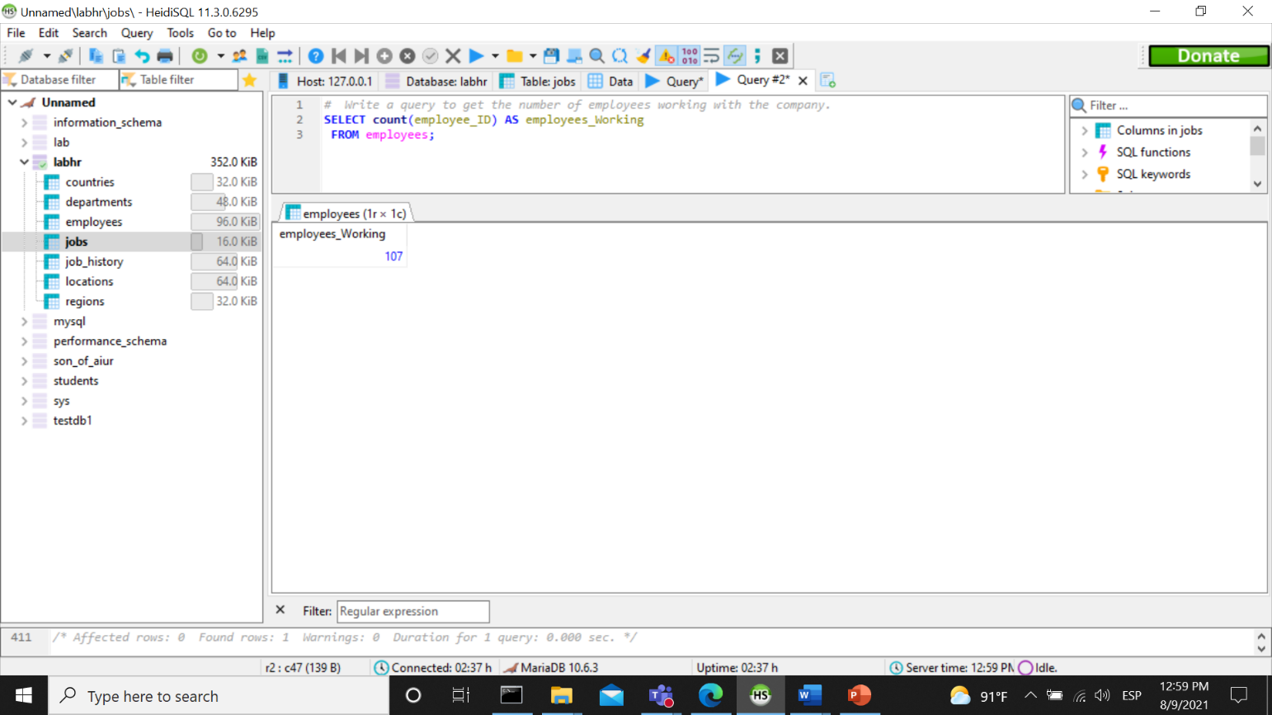
2. Write a query to get the number of jobs available in the employees table.

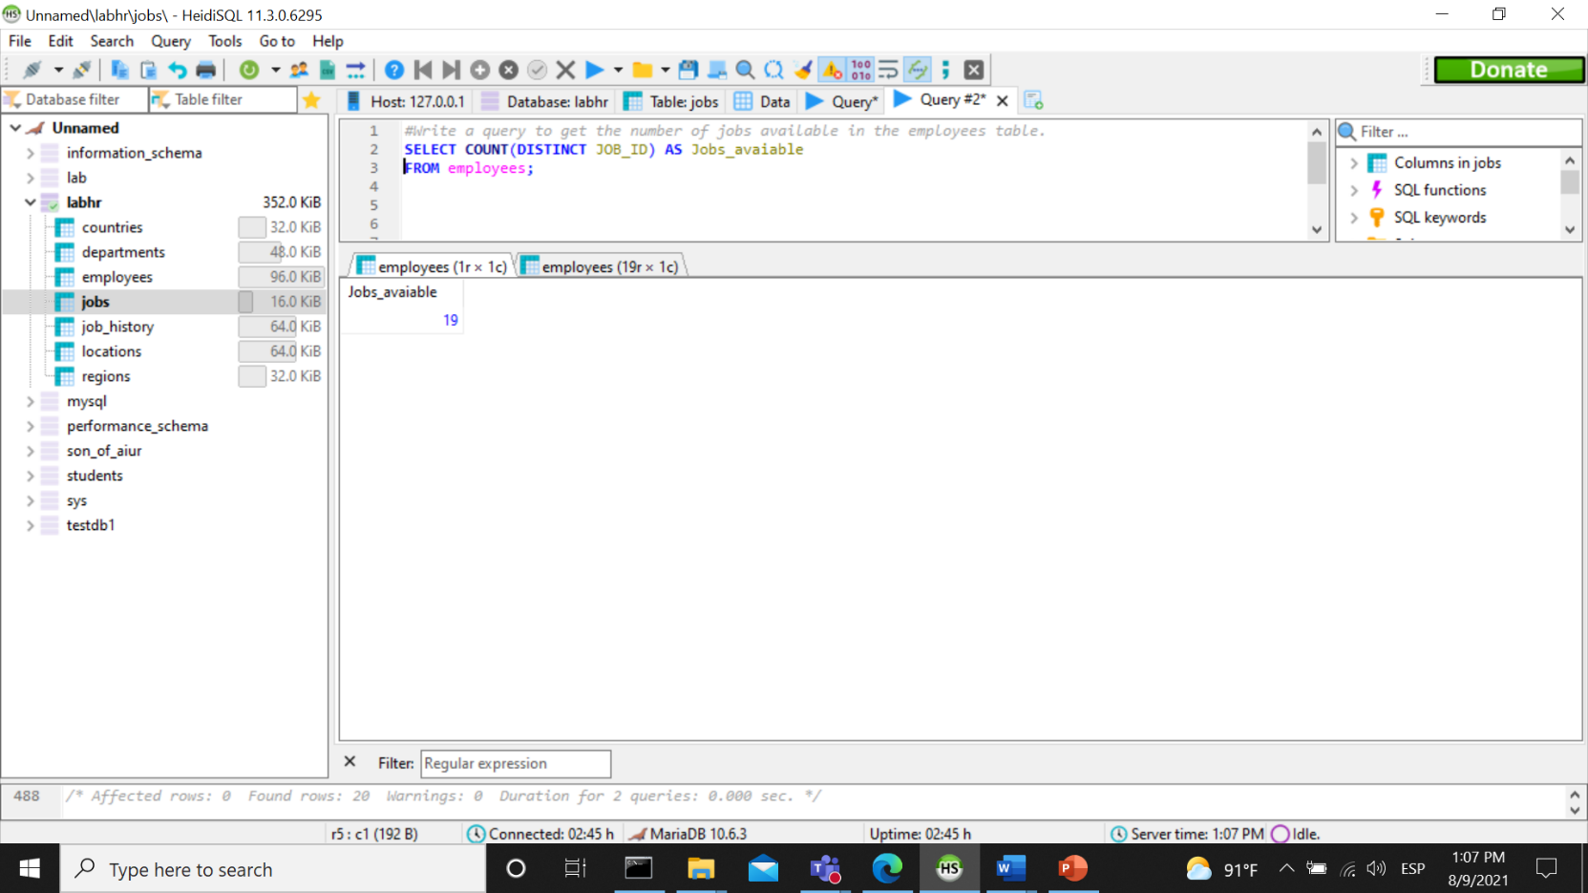

1. Write a query get all first name from employees table in upper case.

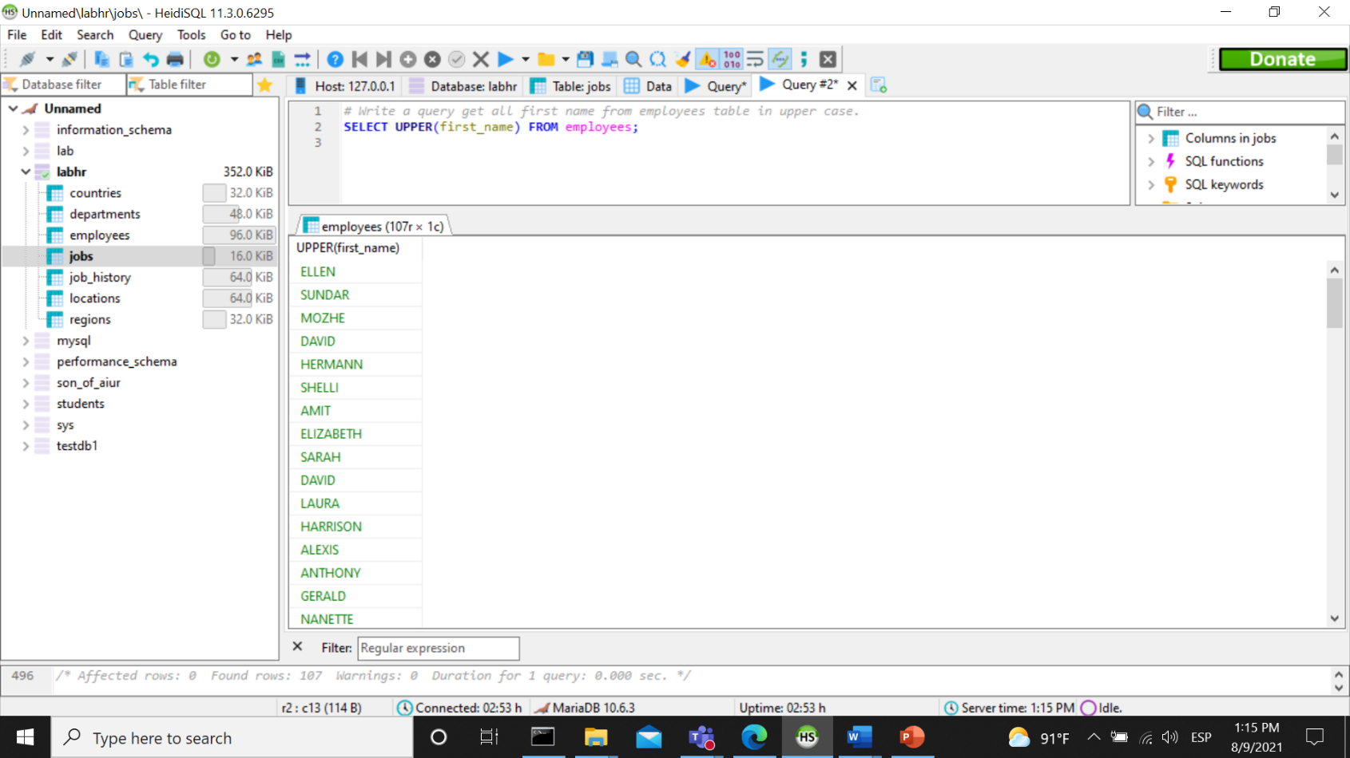

1. Write a query to get the first 3 characters of first name from employees table.

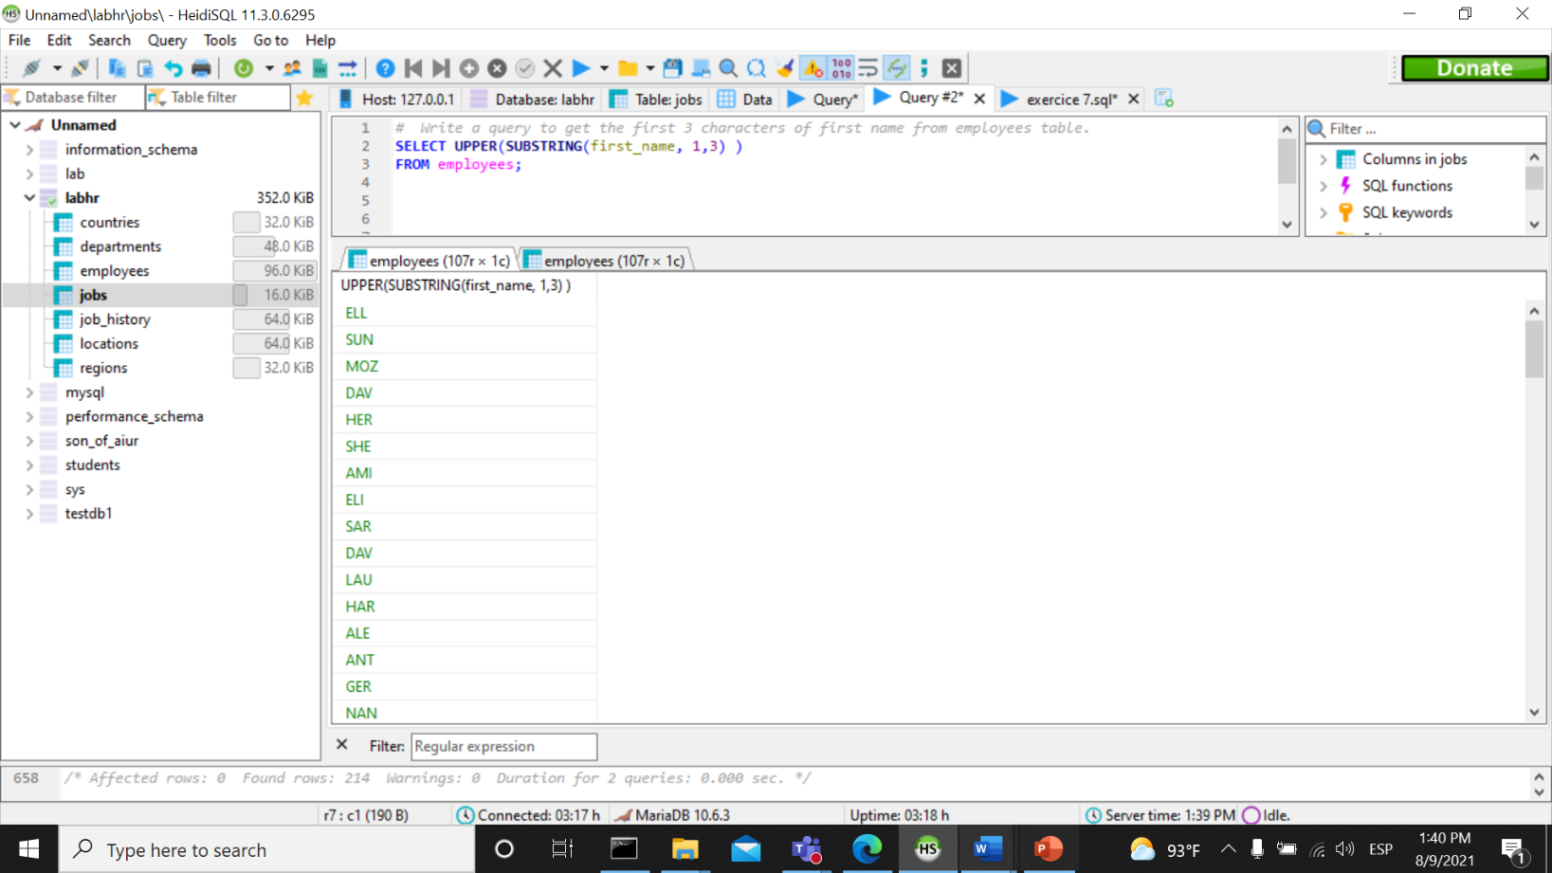

1. Write a query to calculate 171*214+625.

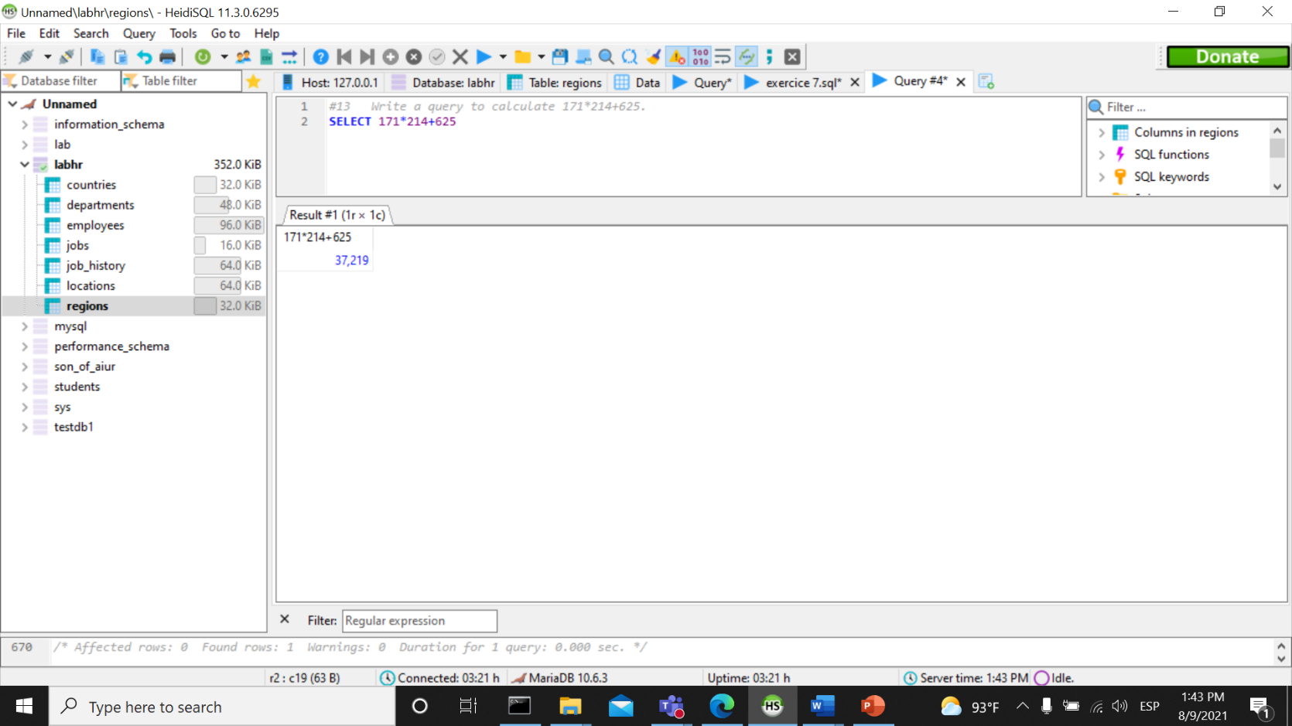

1. Write a query to get the names (for example Ellen Abel, Sundar Ande etc.) of all the employees from employees table.

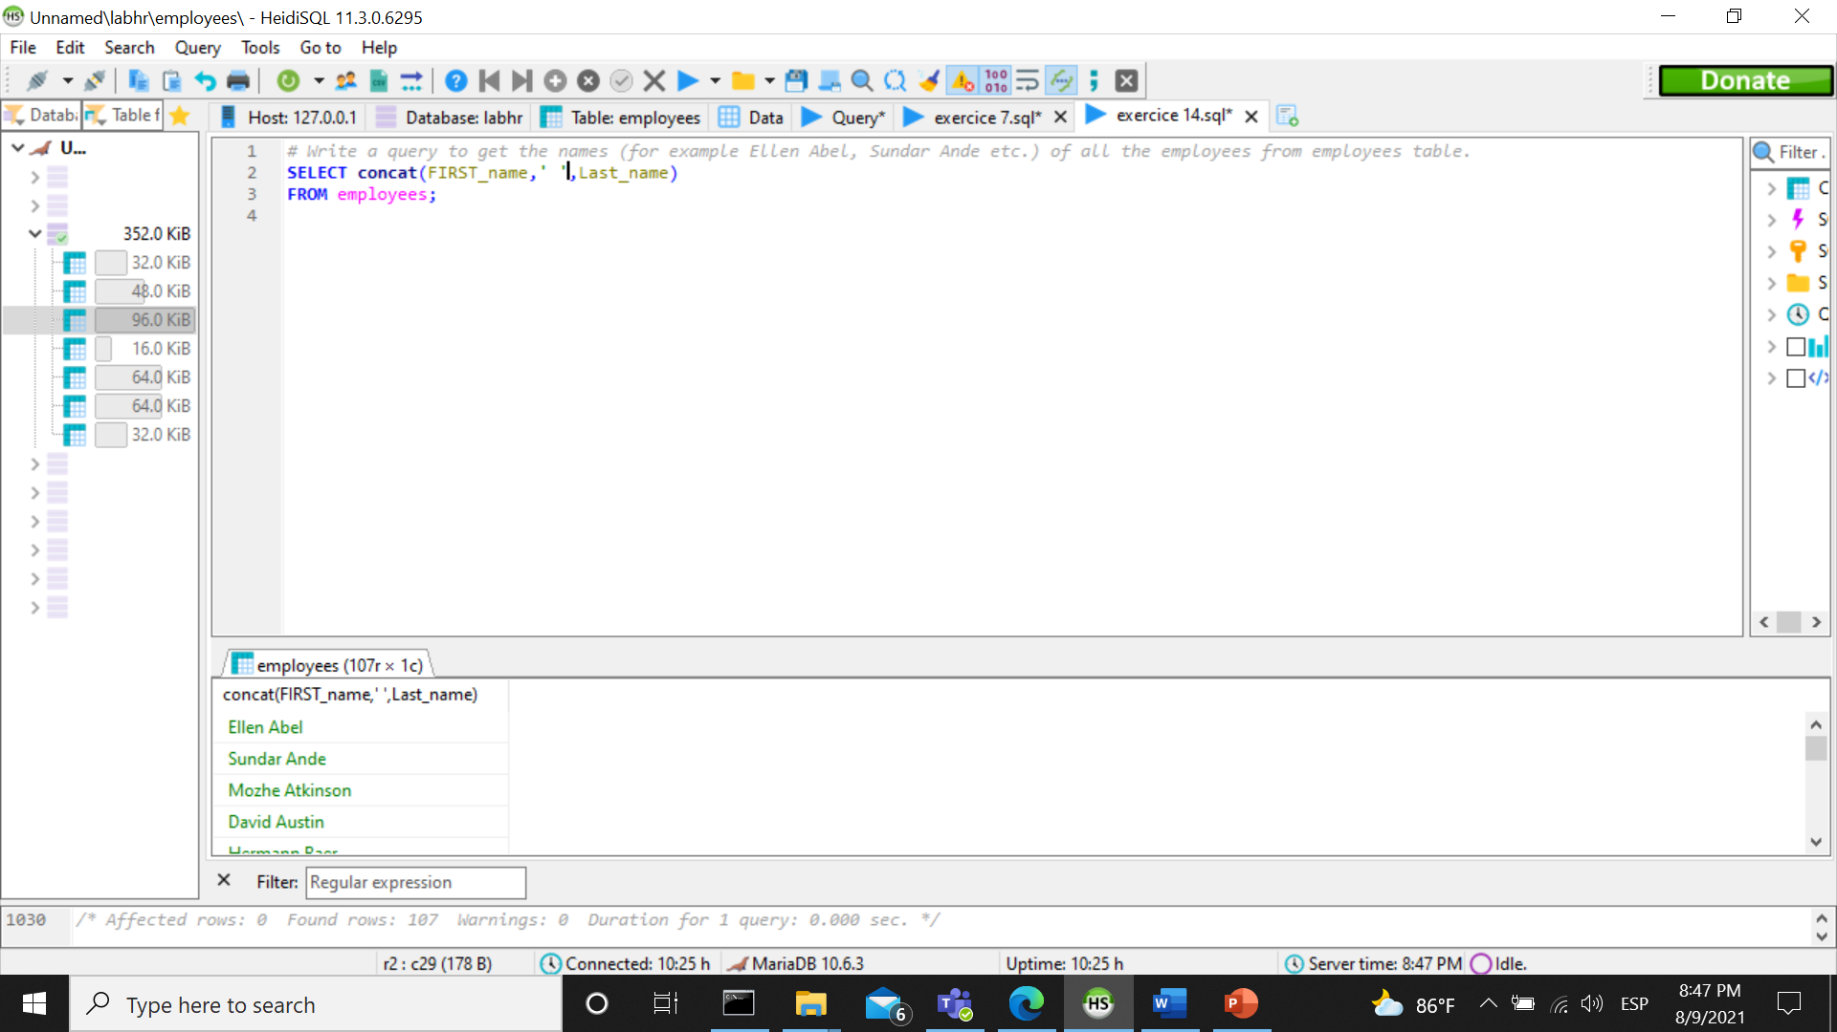

1. Write a query to get first name from employees table after removing white spaces from both side.  
   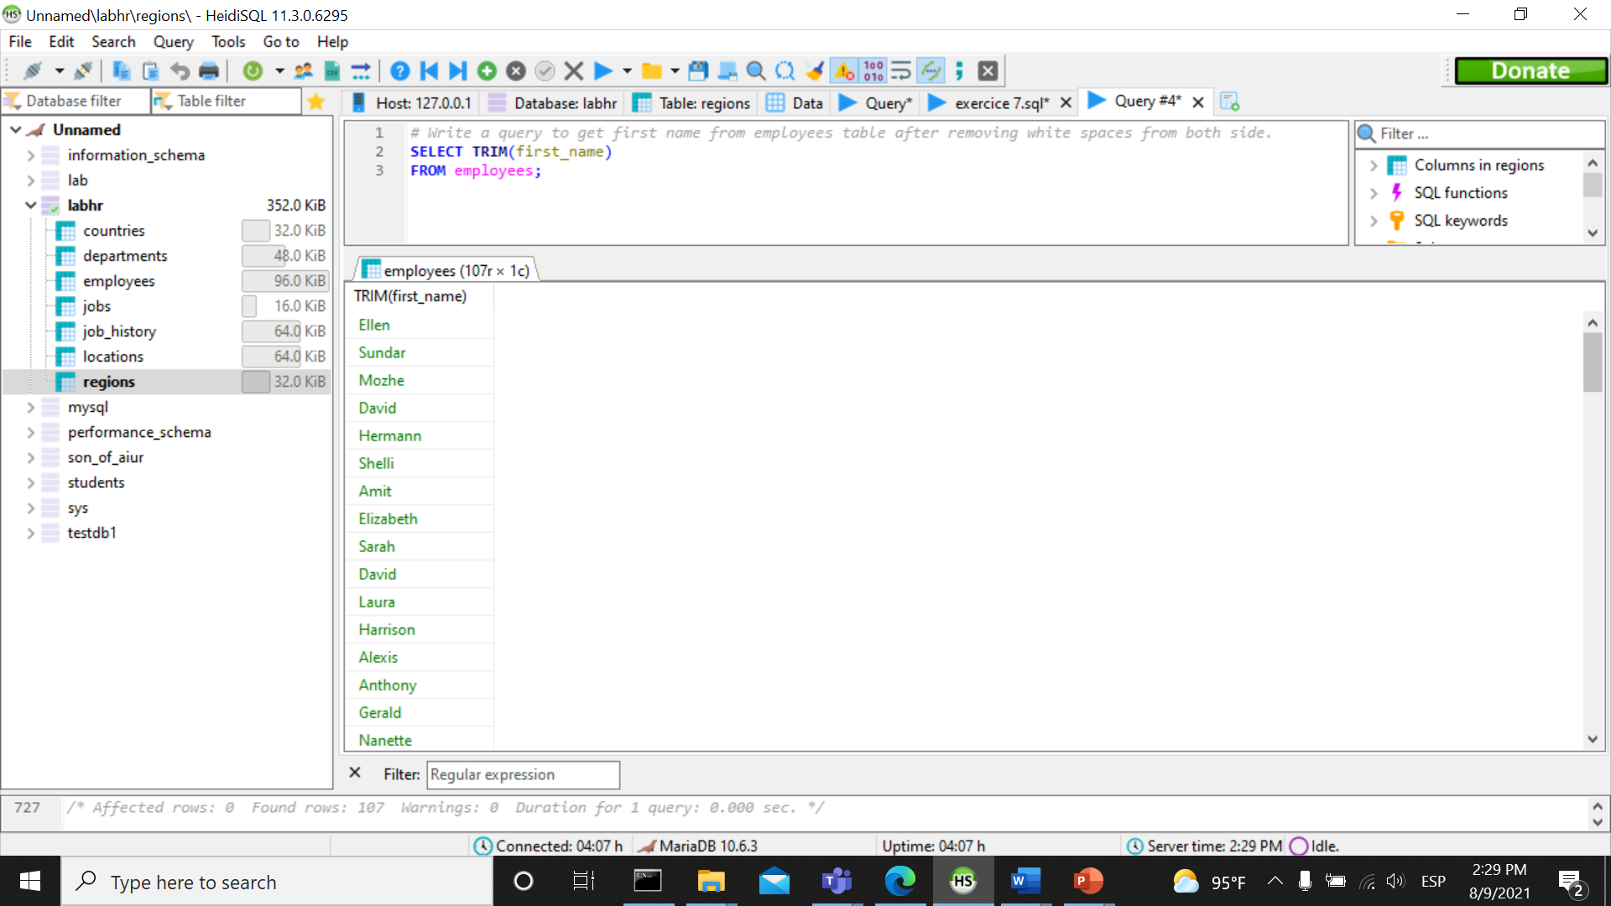
2. Write a query to get the length of the employee names (first_name, last_name) from employees table.

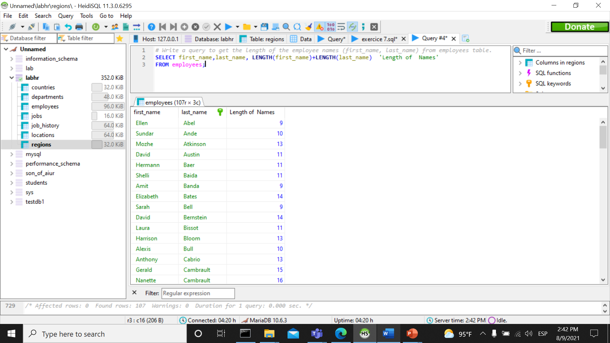

1. Write a query to check if the first_name fields of the employees table contains numbers.

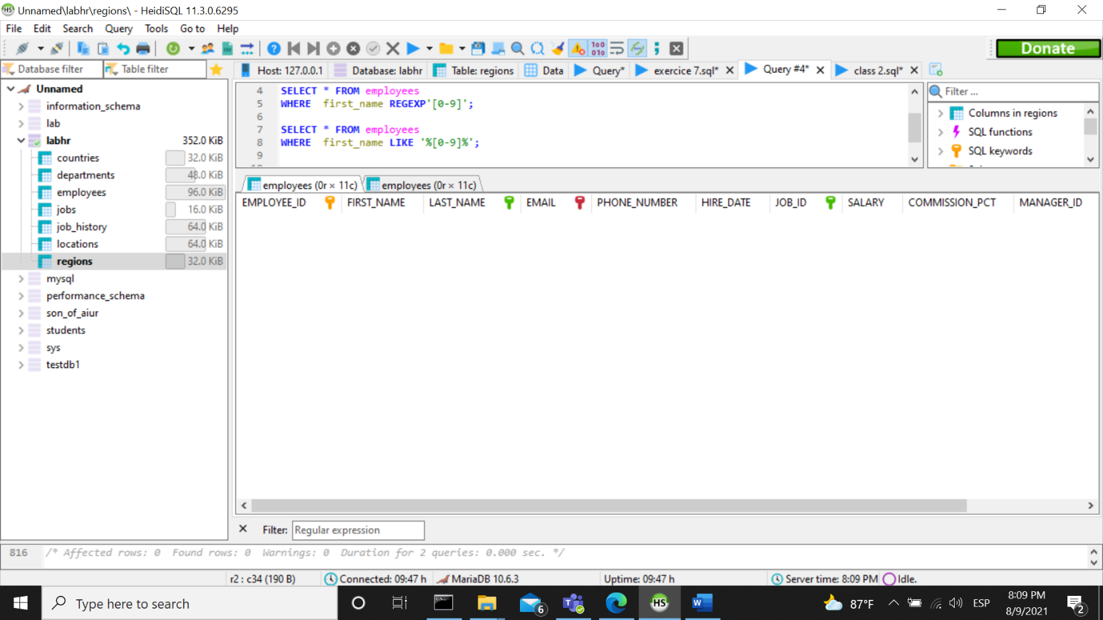

1. Write a query to select first 10 records from a table.

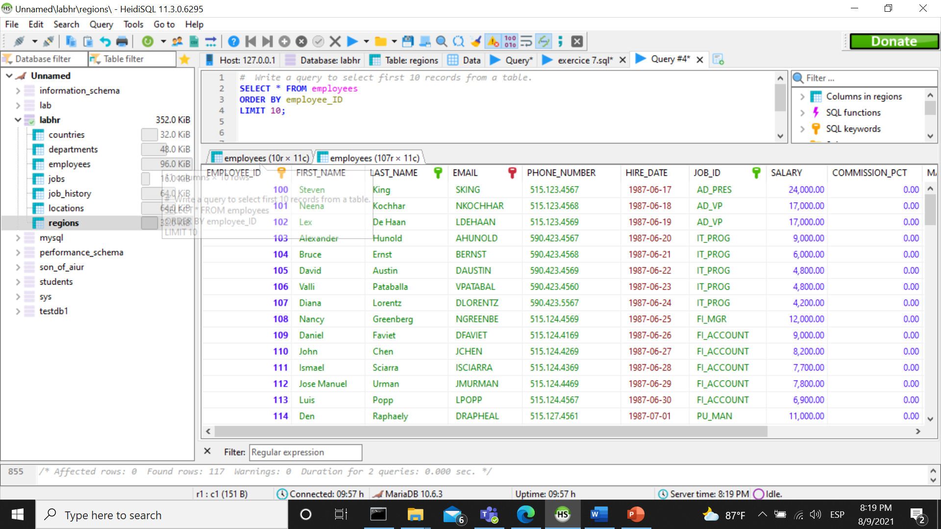

1. Write a query to get monthly salary (round 2 decimal places) of each and every employee.

Note : Assume the salary field provides the 'annual salary' information.

